Experiment 4
Aim: To implement Advanced Text Pre-processing Techniques
Code:
a. Stop word removal, lemmatization, stemming.
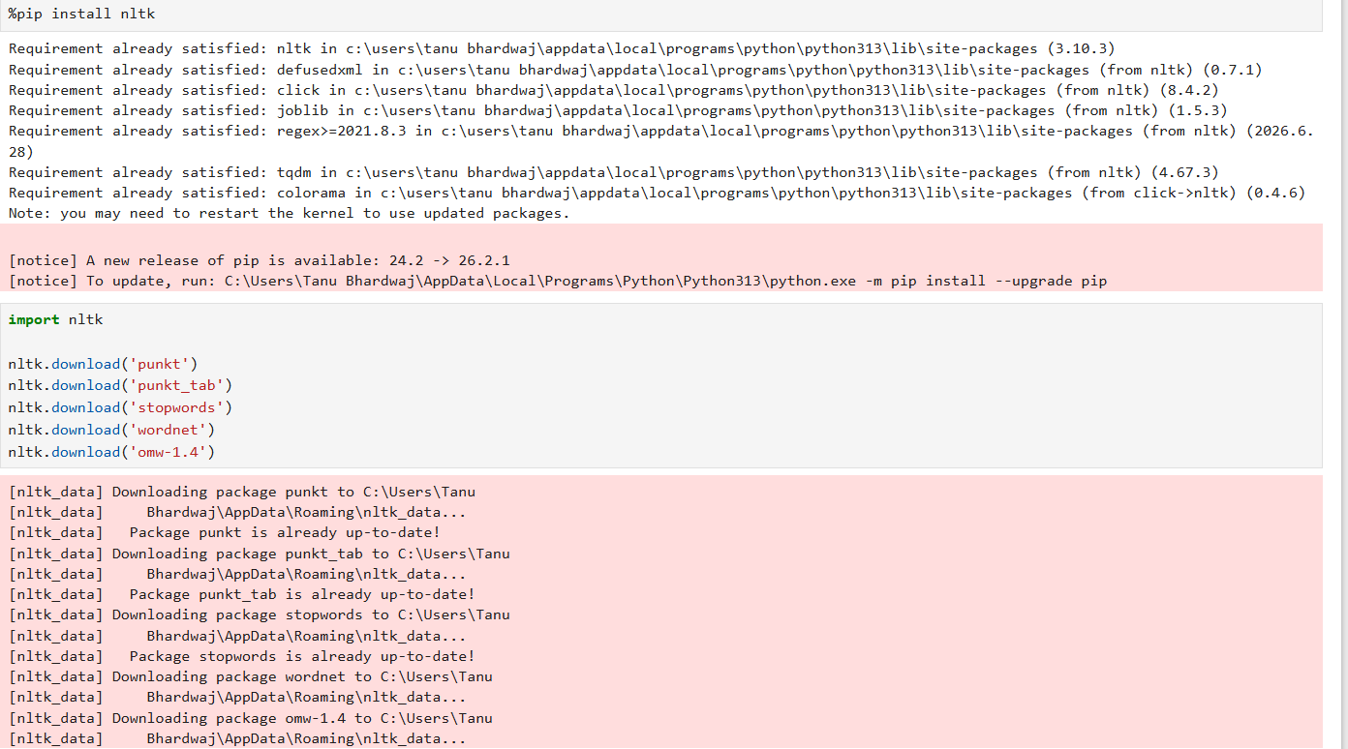
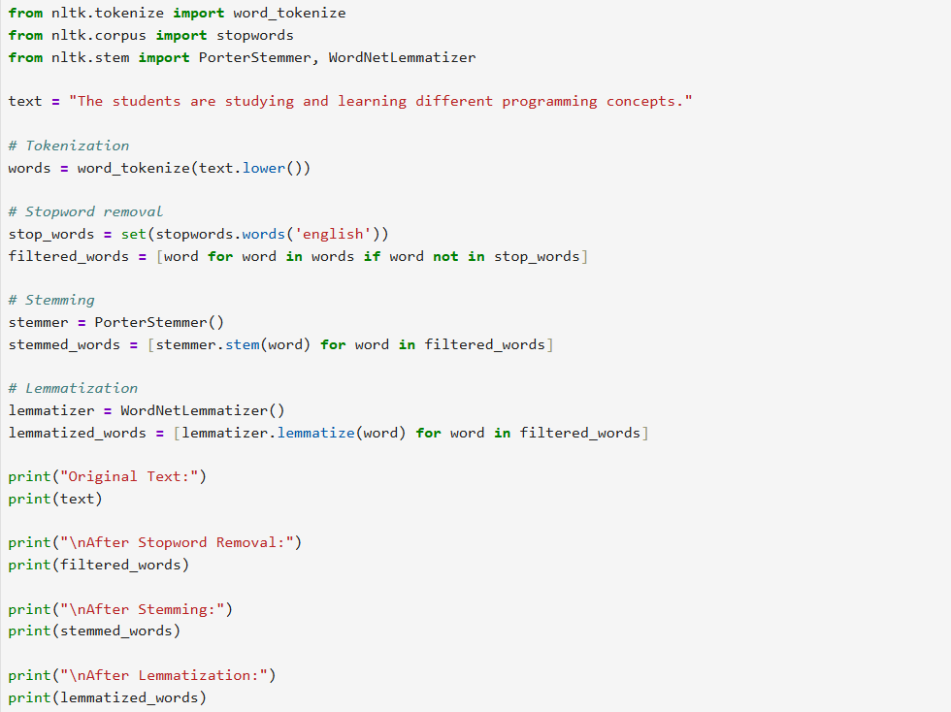
Output:
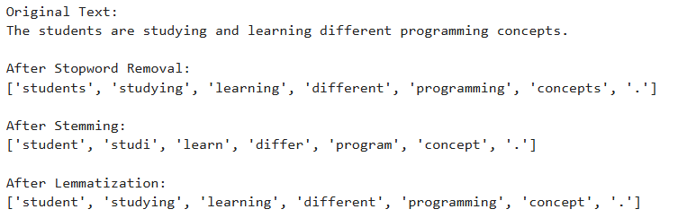
b. Handling noise in text data, multilingual text processing, and entity anonymization.
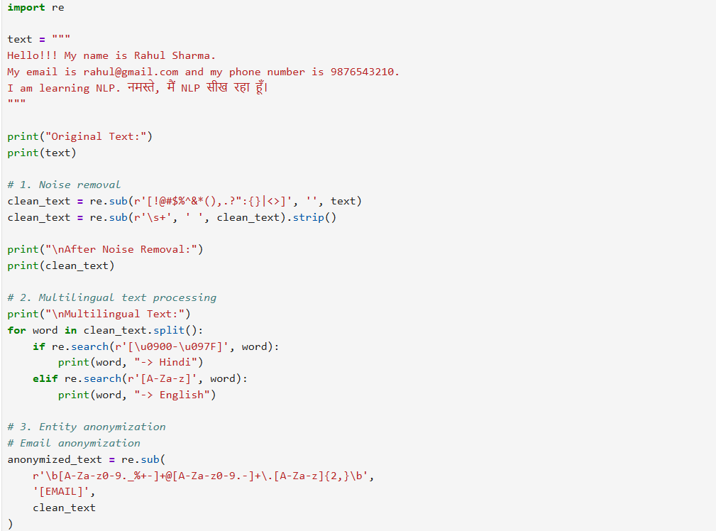

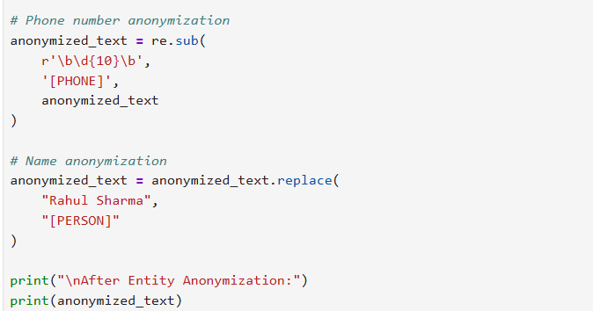
Output:
